Extended Response Questions

Higher Human Biology

Extended response questions
Unit 1

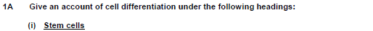

- Cellular differentiation is the process by which a cell expresses certain genes
- to produce proteins characteristic for that type of cell.
- This allows a cell to carry out specialised functions.
- Stem cells are unspecialised somatic cells
- that can divide to make copies of themselves (self-renew)
- and/or differentiate into specialised cells.

(ii and iii) Somatic and germline cells
- A somatic cell is any cell (in the body) other than cells involved in reproduction/germline cells.

- Somatic cells divide by mitosis to form (more) somatic cells.

- Germline cells are gametes/ sperm and egg/ova and (stem) cells that divide/differentiate to form/produce gametes.

- Mitosis of germline cells produces (more) germline cells.

- Meiosis of germline cell produces gametes.

- Meiosis has two stages/divisions.

- First stage/division separates homologous/matching/pairs of chromosomes.

- Second stage/division separates chromatids.

- Somatic cells/germline stem cells are diploid and gametes are haploid.

- Somatic cells/germline cells divide by mitosis to maintain the (diploid) chromosome number/ complement.

- Diploid cells have 23 pairs of homologous/matching chromosomes. OR
Haploid cells/gametes contain 23 single chromosomes/one set of 23 chromosomes.

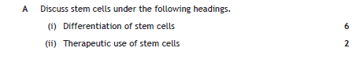

- Cellular differentiation is the process by which a cell expresses certain genes
- to produce proteins characteristic for that type of cell.
- This allows a cell to carry out specialised functions.
- Stem cells are unspecialised somatic cells that can divide to make copies of themselves (self-renew) and/or differentiate into specialised cells.
- Tissue (adult) stem cells are involved in the growth, repair and renewal of the cells found in that tissue.
- Tissue stem cells are multipotent as they can make all of the cell types found in a particular tissue type.
- For example, blood stem cells located in bone marrow can give rise to red blood cells, platelets, phagocytes and lymphocytes.
- Cells in the very early embryo can differentiate into all the cell types that make up the individual and so are pluripotent.
- All the genes in embryonic stem cells can be switched on so these cells can differentiate into any type of cell.
- Therapeutic uses involve the repair of damaged or diseased organs or tissues.
- The therapeutic uses of stem cells are corneal repair and the regeneration of damaged skin.
- Stem cells from the embryo can self-renew, under the right conditions, in the lab.
- There are many ethical issues. Use of embryonic stem cells can offer effective treatments for disease and injury; however, it involves destruction of embryos.

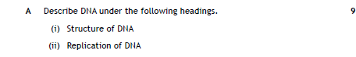

Structure
- DNA is composed of nucleotides containing deoxyribose (sugar), phosphate and base.
- There is a sugar phosphate backbone.
- The four bases are adenine, thymine, cytosine and guanine.
- Cytosine bonds/pairs with Guanine and Adenine bonds with Thymine.
- Bases/two strands are joined by hydrogen bonds.
- Strands are anti-parallel/run in opposite directions/3’ to 5’ and 5’ to 3’.j
- DNA/two strands form a double helix (shape).

Replication
- DNA/double helix is unwound /unzipped.
- A primer is needed at the start of replication/attaches to DNA strand.
- DNA polymerase adds nucleotides to the 3’ end (of a new/growing strand/primer).
- One strand is replicated continuously and the other strand is replicated in fragments/discontinuously.
- The strand replicated in fragments is joined together by ligase.

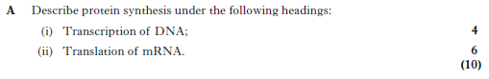

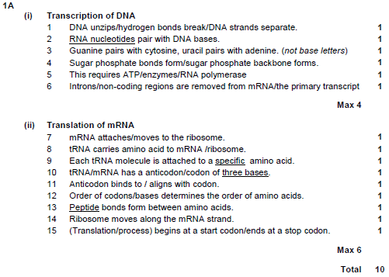
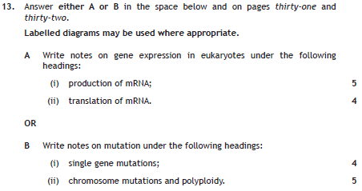

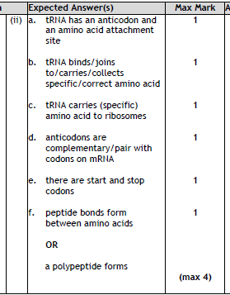
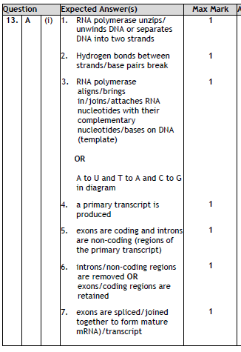
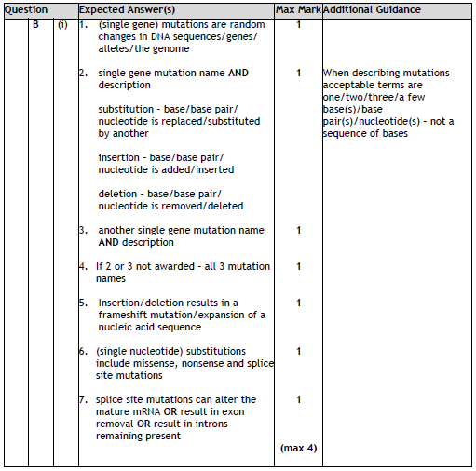
4
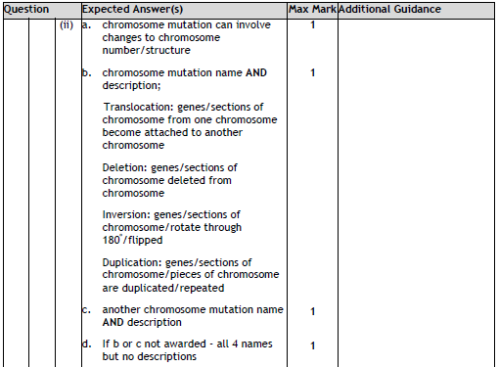
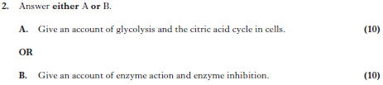
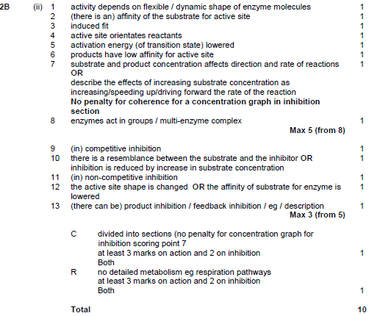
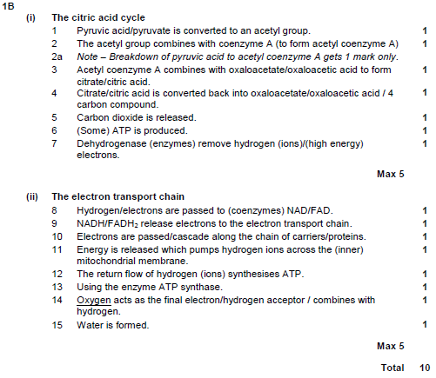
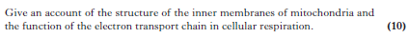
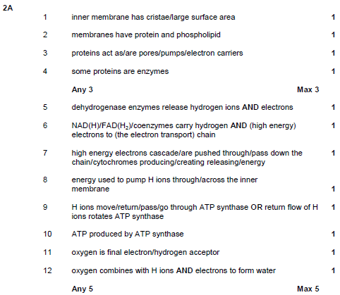

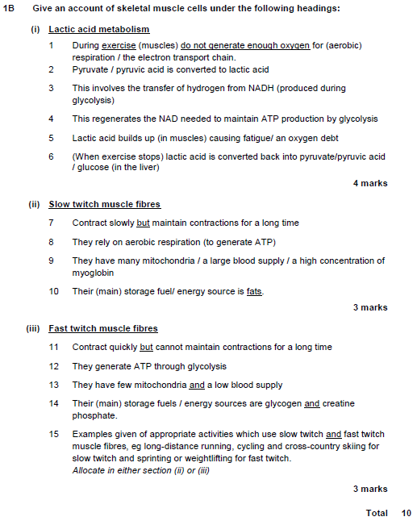
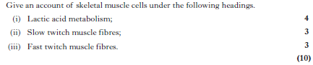
Unit 2
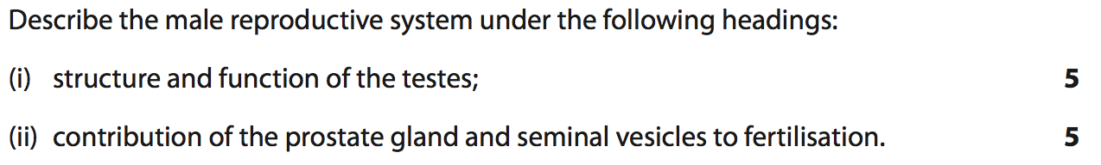
- Gametes are produced from germline cells.
- Testes produce sperm
- in the seminiferous tubules
- and testosterone
- in the interstitial cells.
- The prostate gland and seminal vesicles secrete fluids
- that maintain the mobility and viability of the sperm.
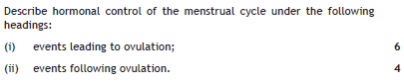

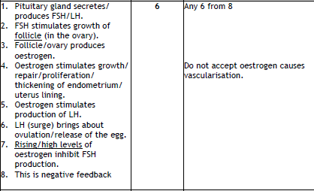
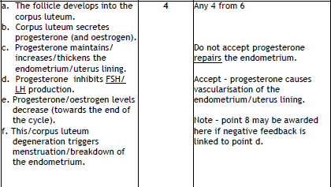
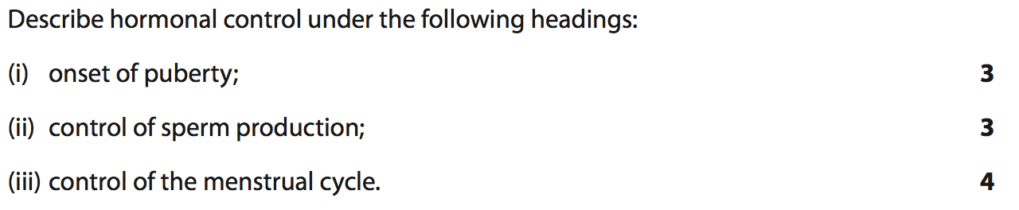
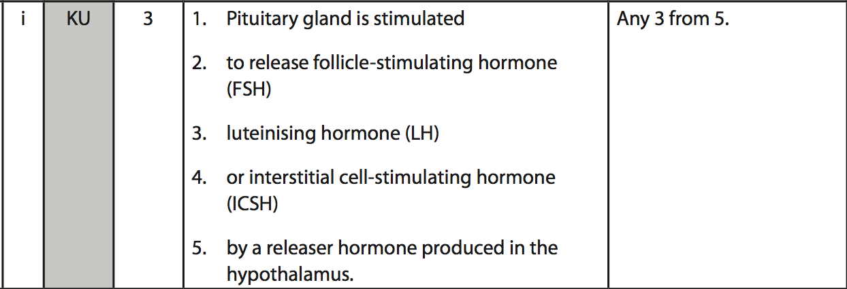
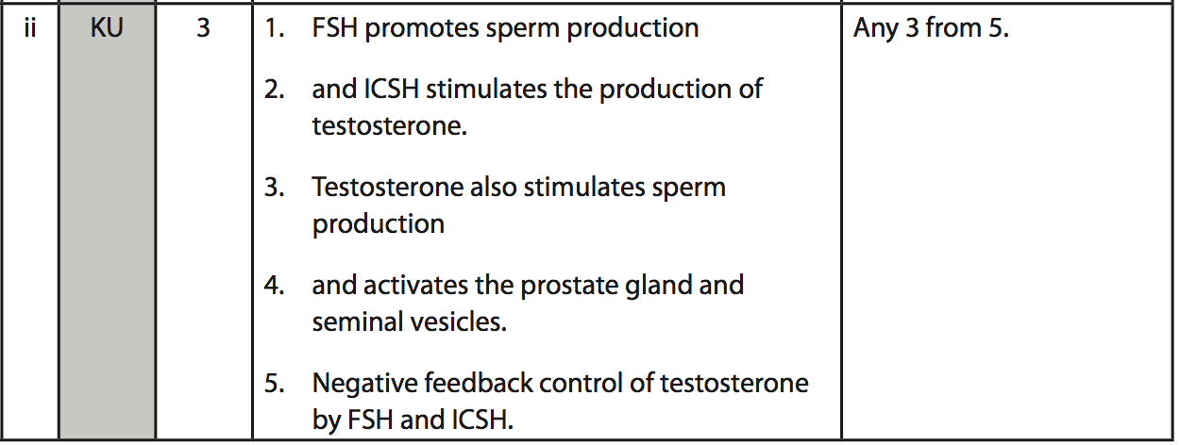
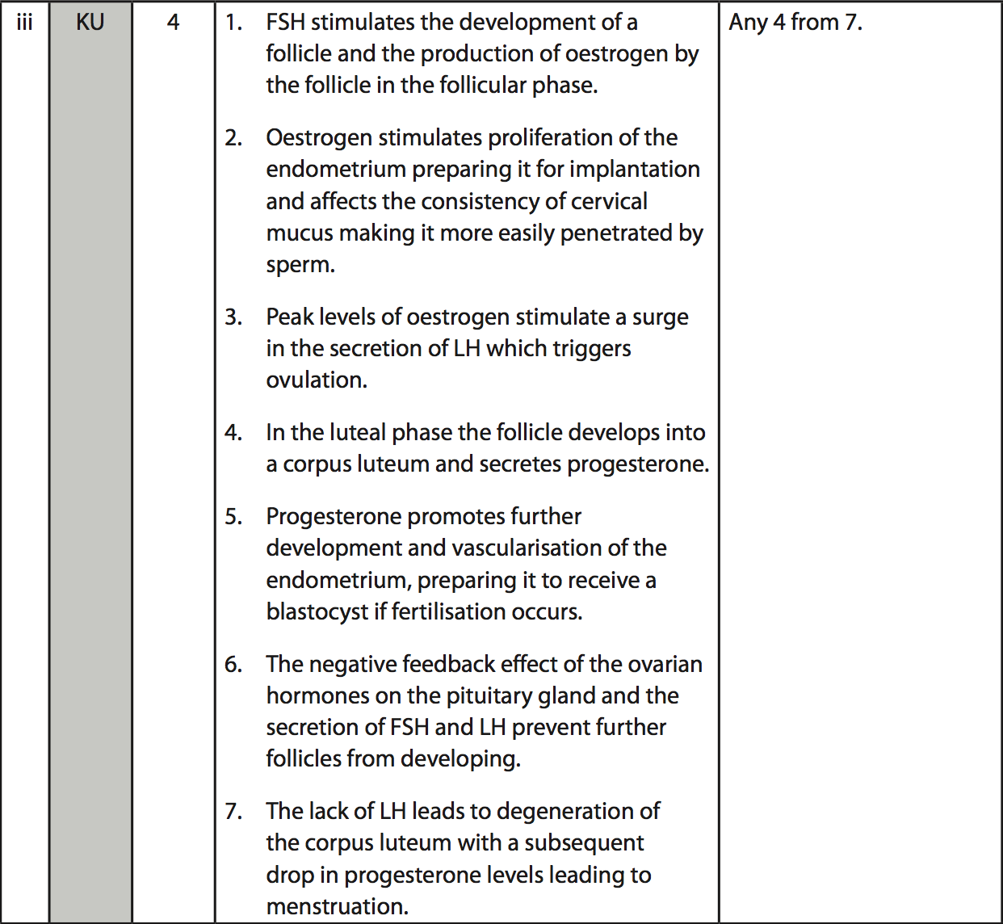
1. At puberty a (releaser) hormone is produced by the hypothalamus.
2. The pituitary gland releases follicle stimulating hormone/FSH and interstitial cell stimulating hormone /ICSH.
3. FSH/ICSH acts on/targets the testes.
4. FSH stimulates sperm production in the seminiferous tubules.
5. ICSH stimulates the production of testosterone in the interstitial cells.
6. Testosterone stimulates sperm production.
7. Sperm/gametes are produced from germline cells by meiosis.
8. Testosterone activates the prostate gland/seminal vesicles.
9. Secretions affect/maintain sperm mobility/viability or named example
10. Negative feedback control / feedback inhibition of sperm / testosterone production exists.
11. High levels of testosterone inhibits/reduces/controls FSH/ICSH production.
8 marks from 11

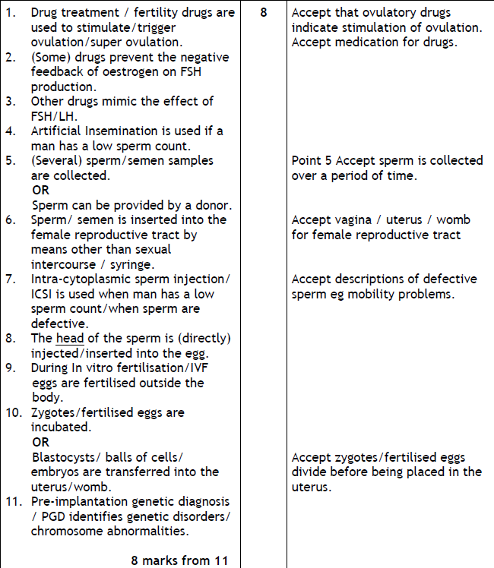
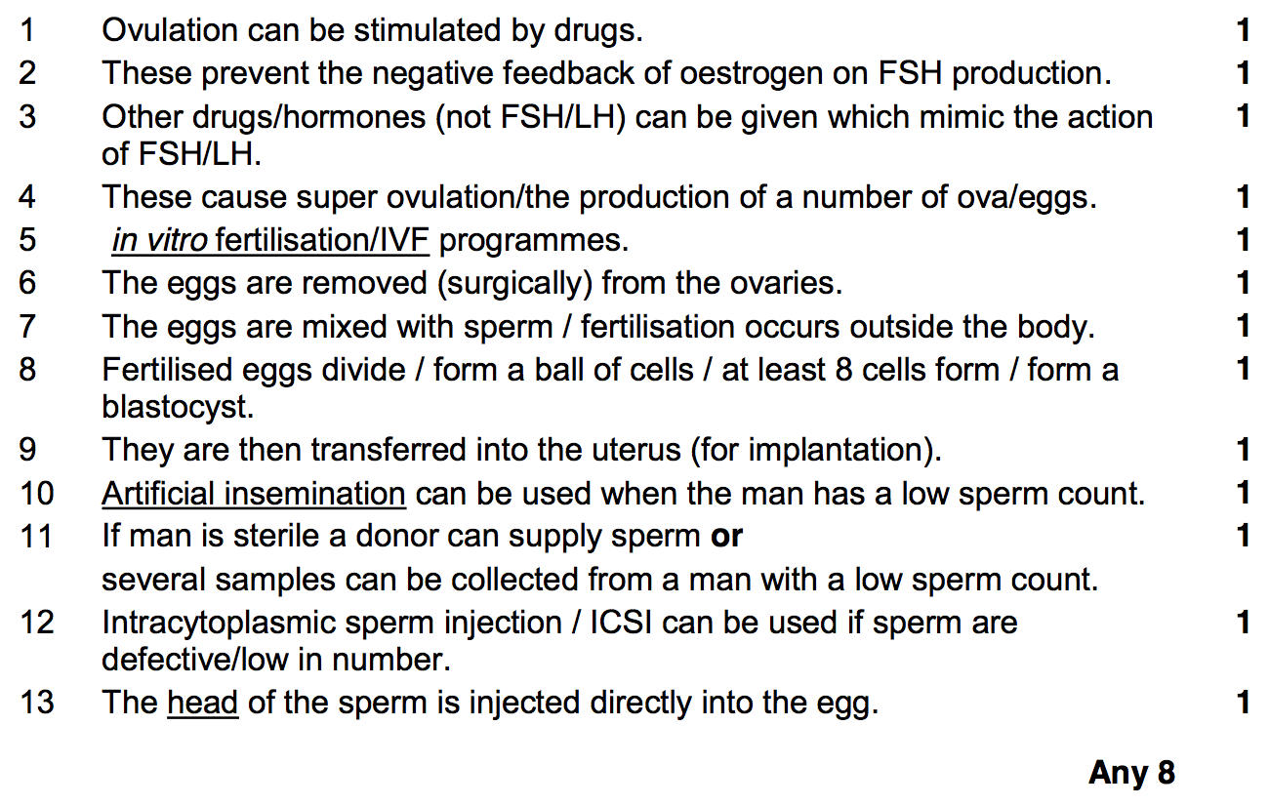

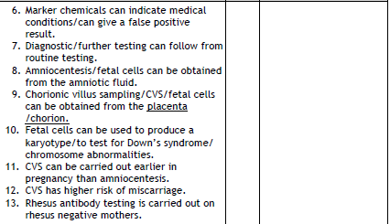
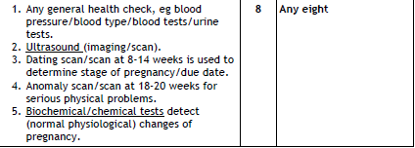
2021
Discuss the use of antenatal screening and diagnostic testing to monitor the health of the developing fetus during pregnancy.

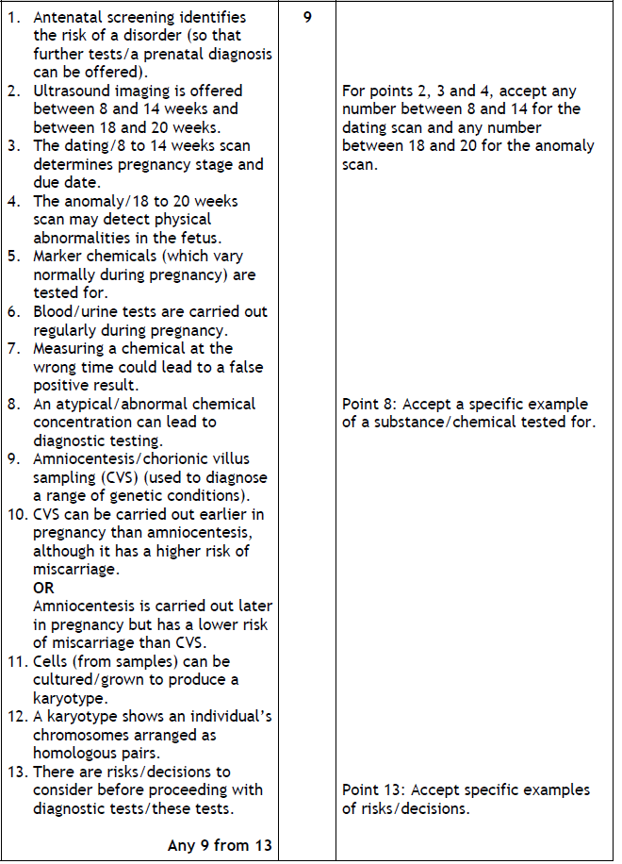
Describe fertility under the following headings:
- Treatments for female infertility (5)
- Physical and chemical methods of contraception (4)

(i) Treatments for female infertility

- Ovulation can be stimulated by drugs.
- These prevent the negative feedback of oestrogen on FSH production.
- Other drugs/hormones (not FSH/LH) can be given which mimic the action
of FSH/LH.
- These cause super ovulation/the production of a number of ova/eggs.
- in vitro fertilisation/IVF programmes.
- The eggs are removed (surgically) from the ovaries.
- The eggs are mixed with sperm / fertilisation occurs outside the body.
- Fertilised eggs divide / form a ball of cells / at least 8 cells form / form a blastocyst.
- They are then transferred into the uterus (for implantation).

(ii) Physical and chemical methods of contraception

- Physical methods such as barrier methods, (or example, e.g. condom)
- avoiding fertile periods,
- intra uterine devices
- and sterilisation procedures.
- Chemical contraceptives are based on combinations of synthetic hormones that mimic negative feedback preventing the release of FSH/LH.
- Some prevent implantation (‘morning-after pills’)
- or cause thickening of cervical mucus (‘progesterone- only pill’).

Give an account of pedigree charts and patterns of inheritance (7)
- pedigree charts are used to analyse patterns of inheritance
- in genetic screening and counselling
- single gene disorders
- autosomal recessive require 2 defective recessive autosomal alleles to express condition
- autosomal dominant require 1 defective autosomal dominant allele to express condition
- incomplete dominance caused by an autosomal defective allele
- in the homozygous state produces the maximum expression of the phenotype
- in the heterozygous state produces a reduced expression of the phenotype
- sex-linked recessive caused by a defective sex-linked recessive allele
- all daughters of affected fathers will either be carriers or be affected themselves
- will be expressed in a male who has one copy of the defective allele
- needs an individual to be homozygous if they are female

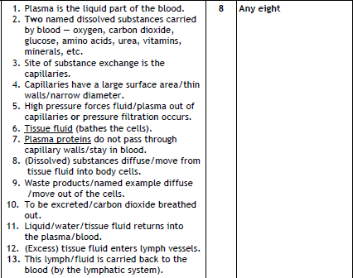

2021
Discuss the structure and function of arteries, veins and capillaries in the circulatory system (9)

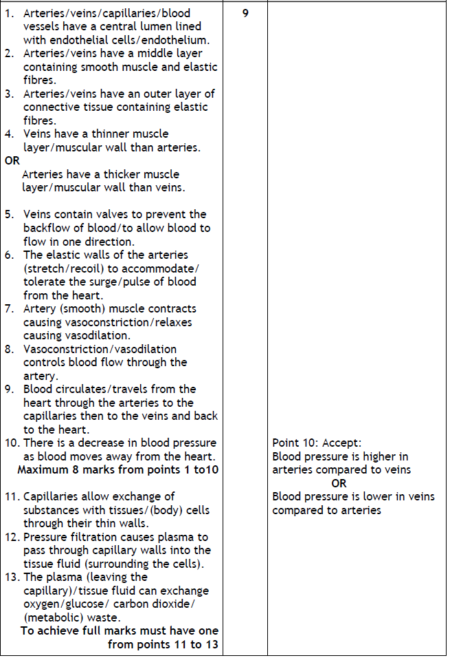
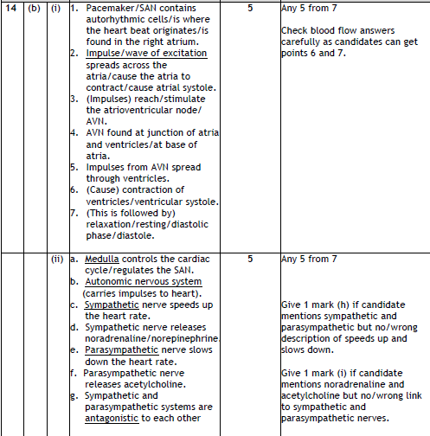
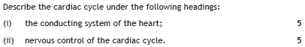
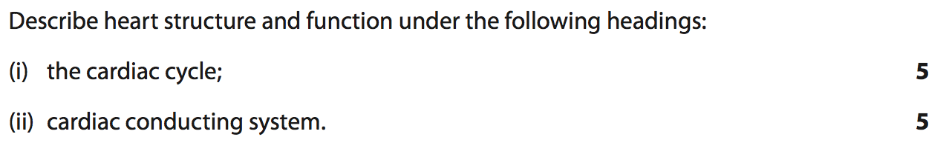
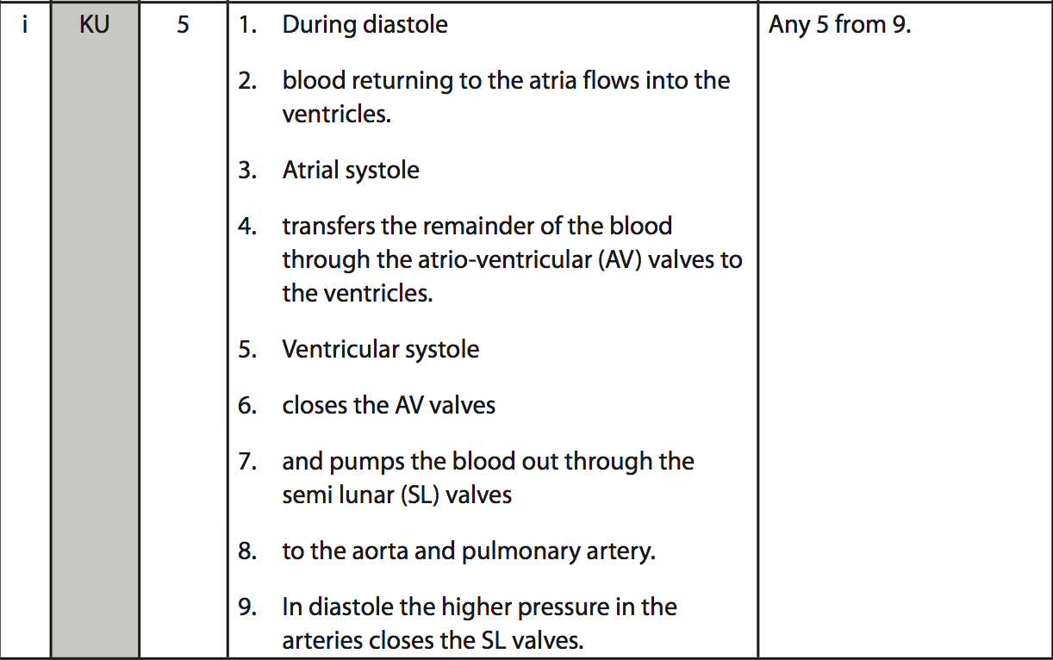
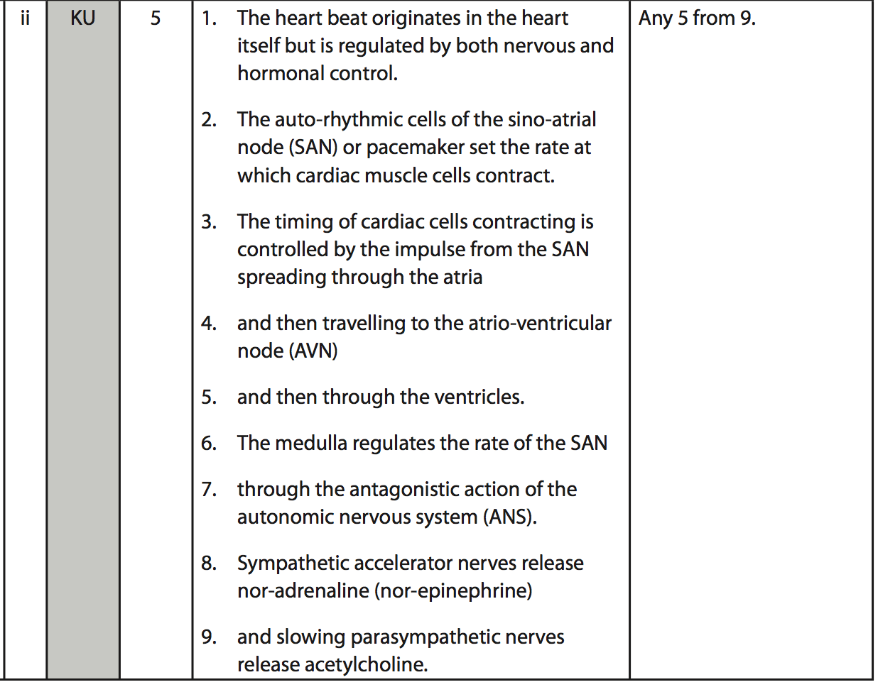
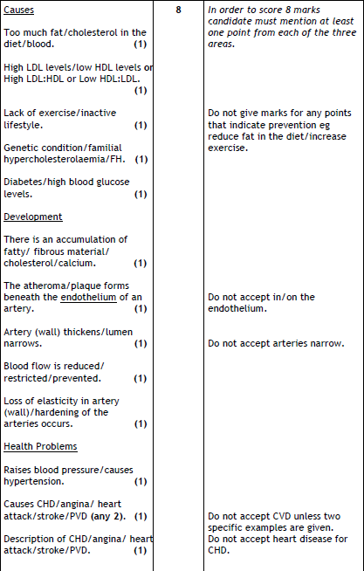
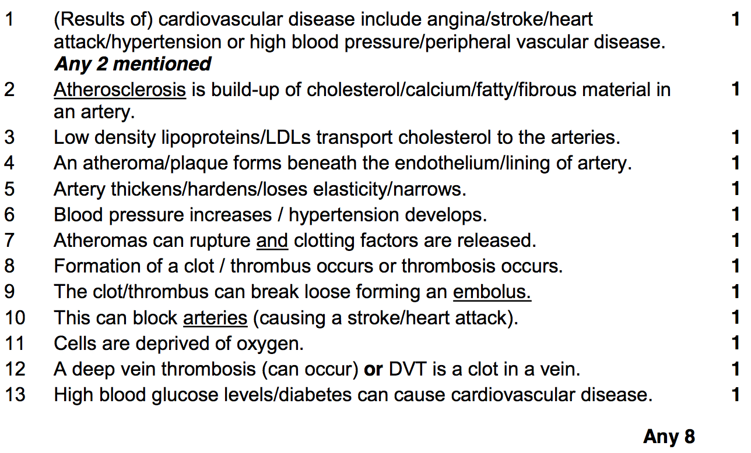

2022
Discuss the formation of a thrombus and the damaging effects it can cause in the body. (9)
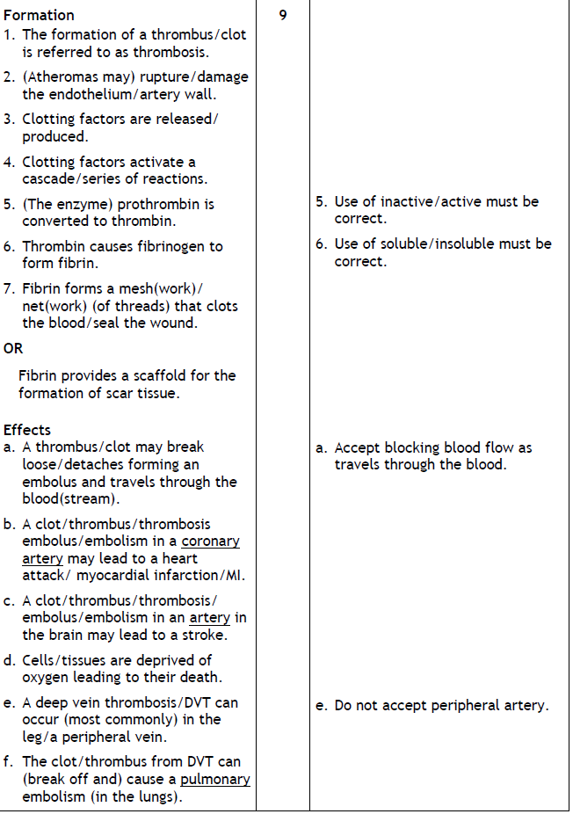
2022
Discuss the production, transport, and role of cholesterol in the body. (9)
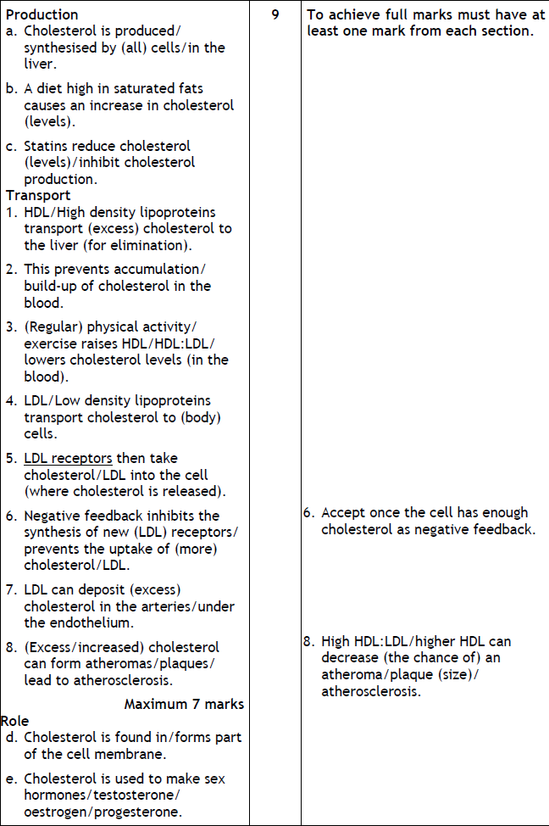

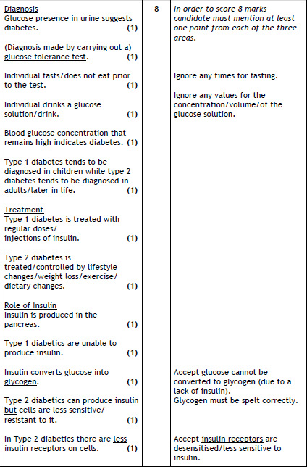
Unit 3
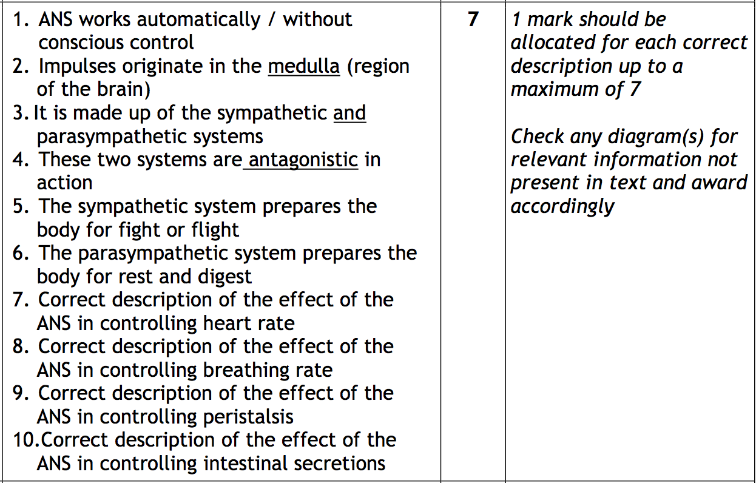

Give an account on the localisation of brain function. 8
- Brain functions are localised into different areas.
- sensory
- motor
- association areas
- Some association areas deal with
  - thought processes,
  - language,
  - personality,
  - imagination
  - and intelligence. (Max 2)
- Information from one side of the body is processed in the opposite side of the cerebrum
- transfer of information occurs through the corpus callosum
- The left cerebral hemisphere deals with information from the right visual field
- and controls the right side of the body
- and vice versa

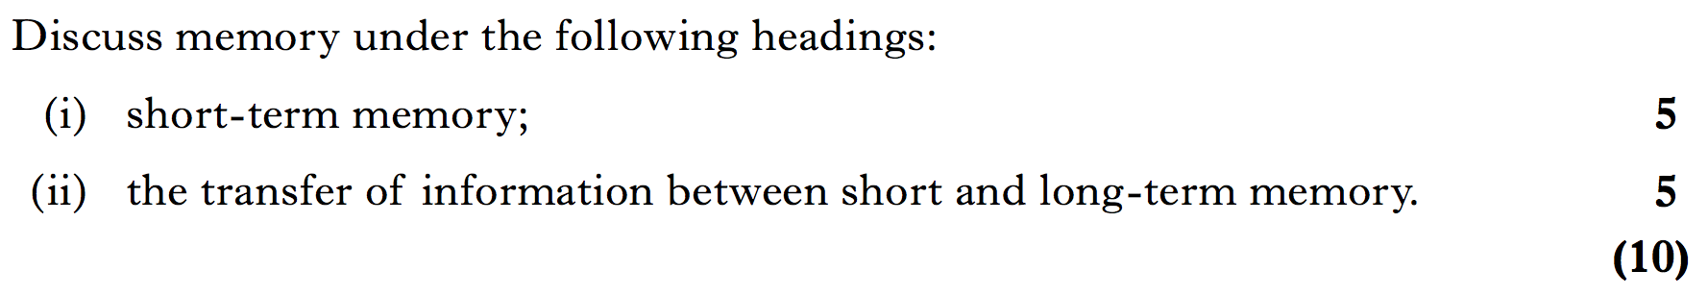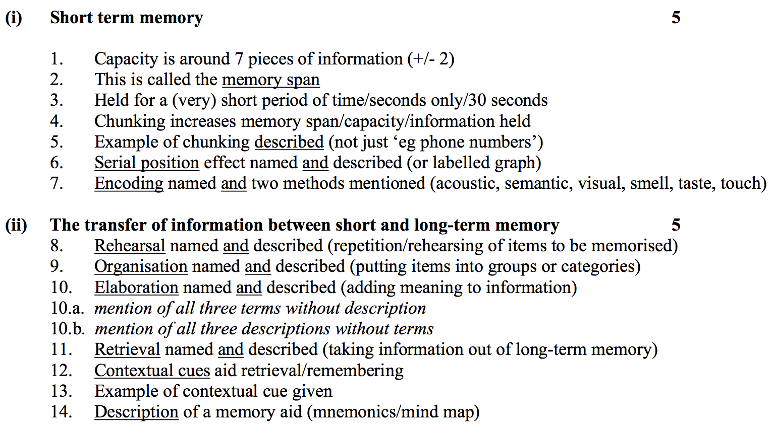

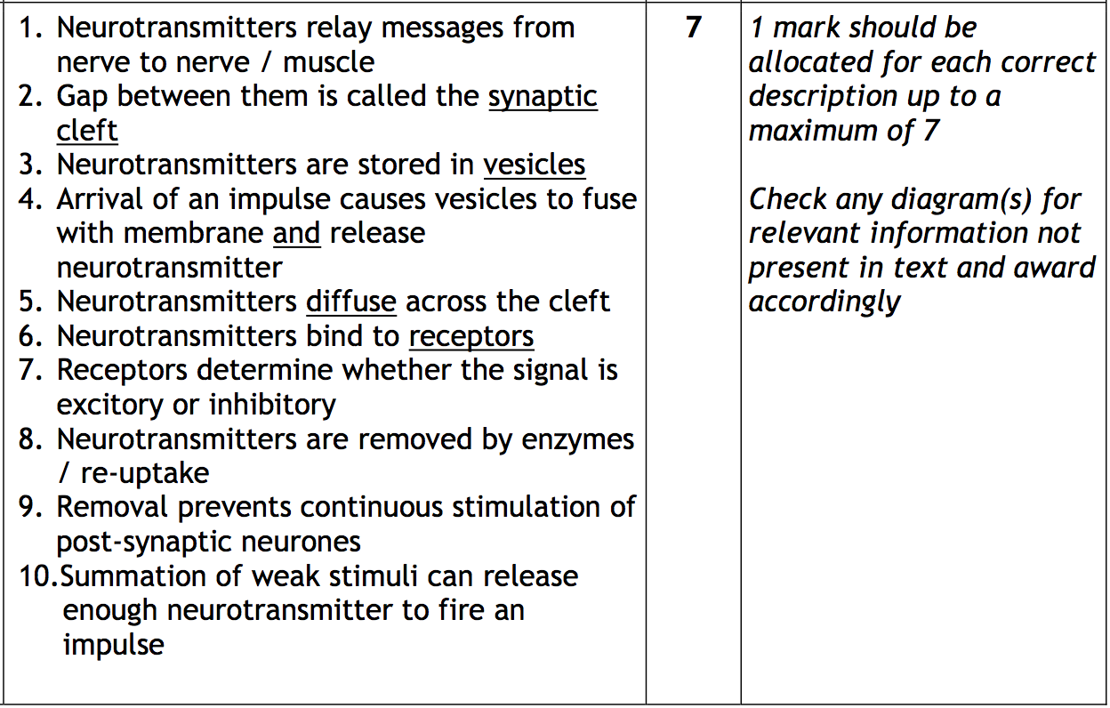

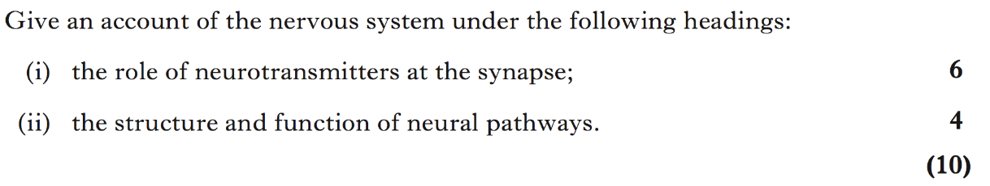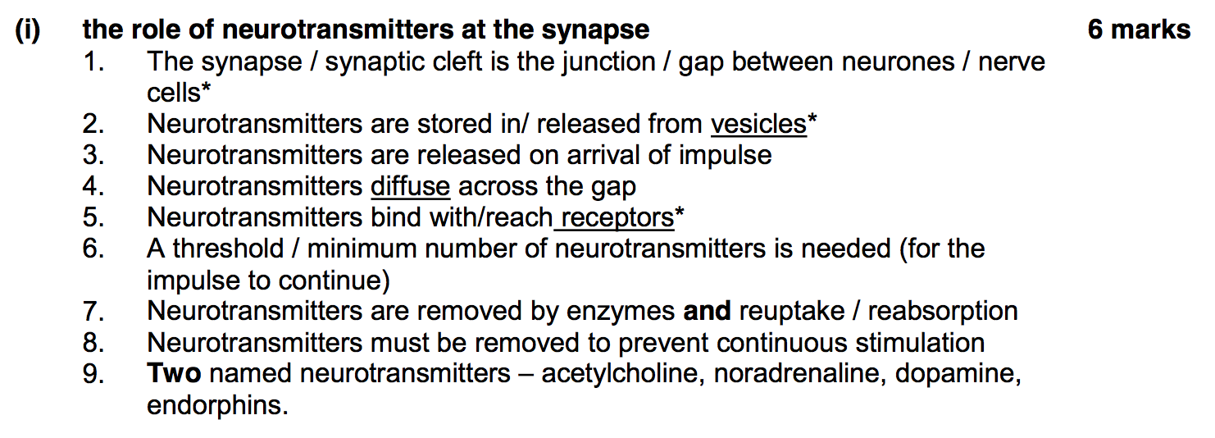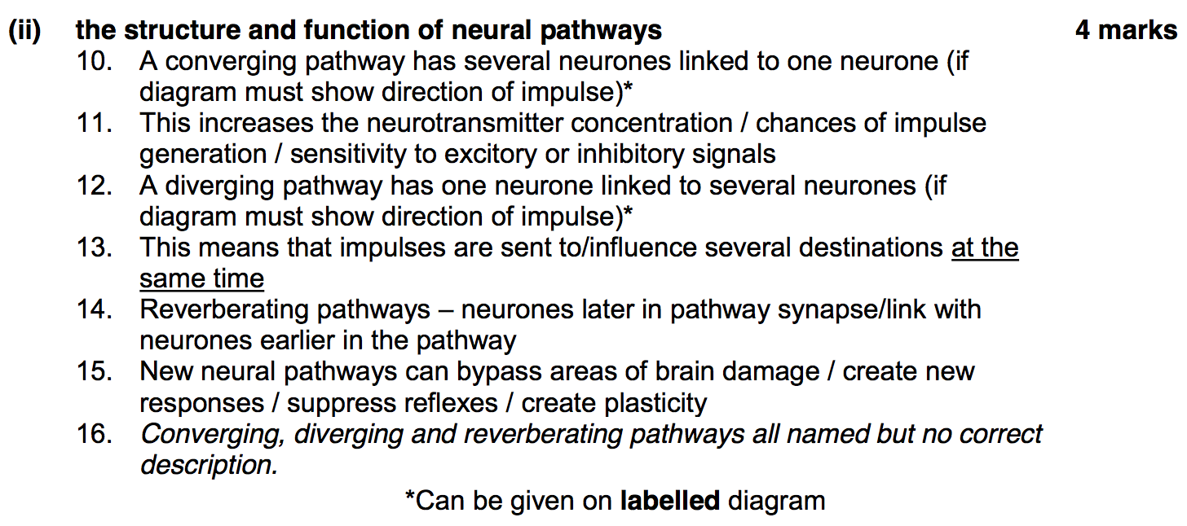

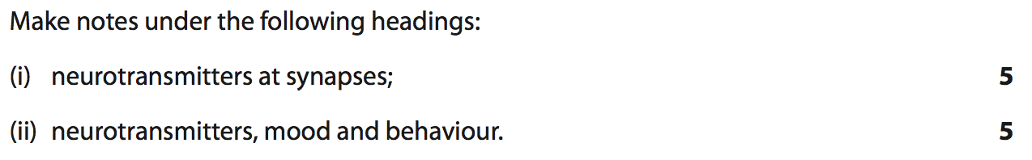
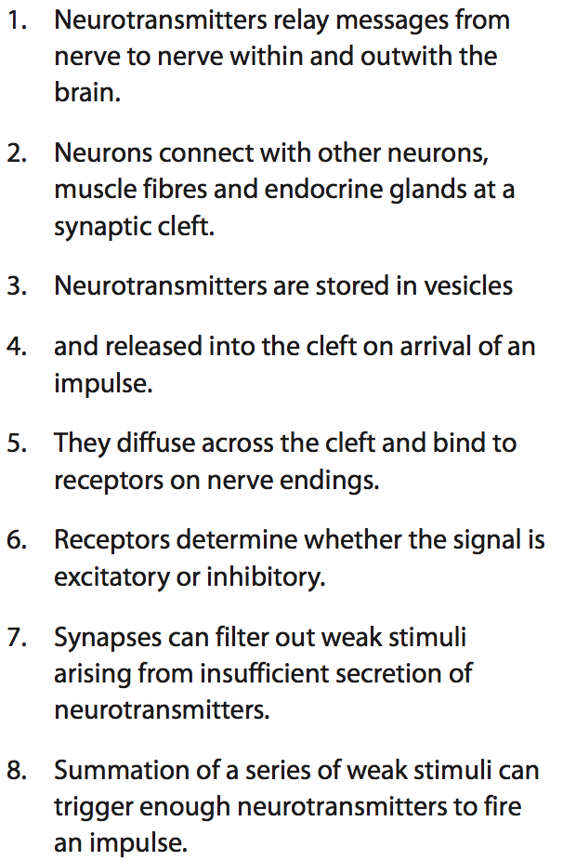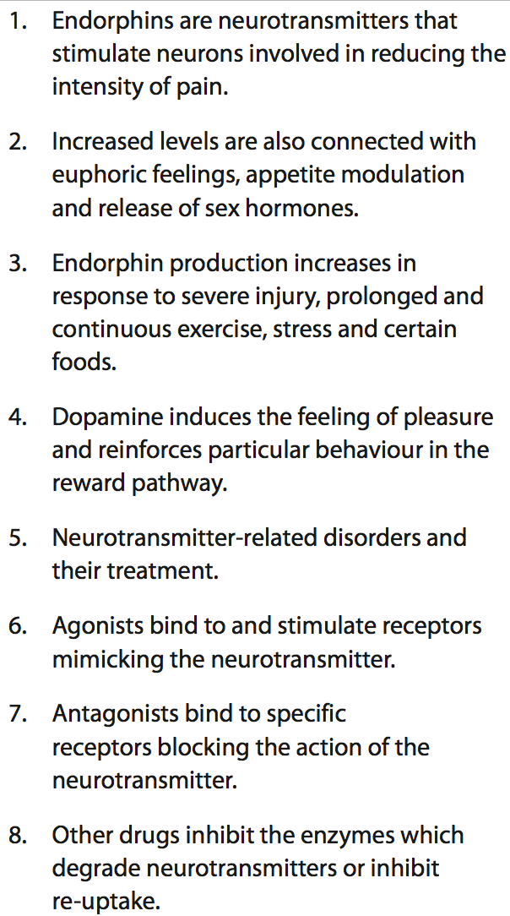

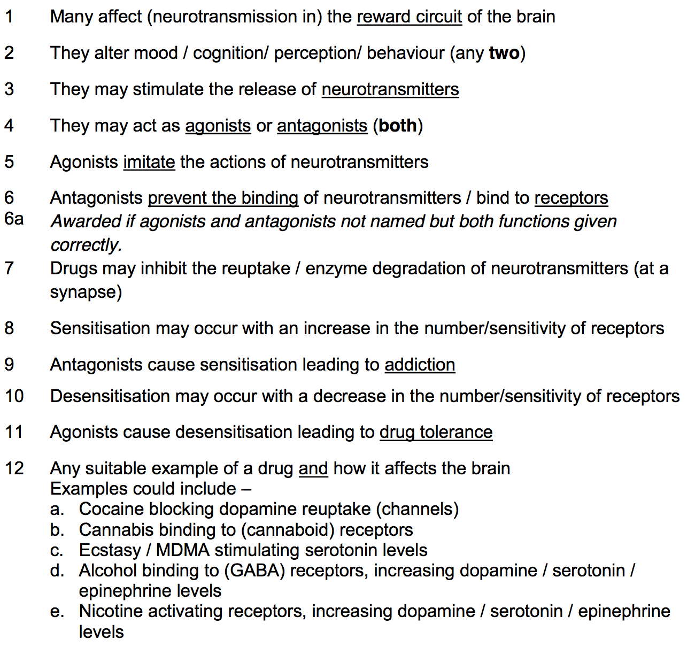
2023
Describe the mode of action of recreational drugs and the effects on the body of their repeated use. (9)
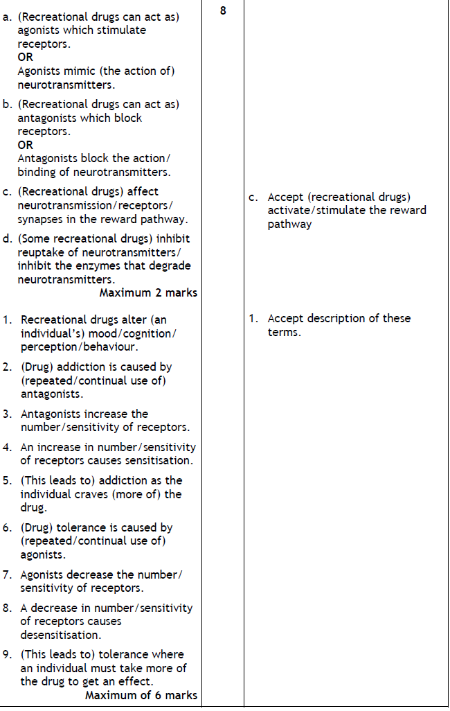
Give an account of the non-specific immune response under the following headings
- Inflammatory response (5)
- Phagocytes and apoptosis by natural killer (NK) cells (5)

- Inflammatory response
- release of histamine by mast cells
- causing vasodilation and increased capillary permeability.
- The increased blood flow and secretion of cytokines
- leads to an accumulation of phagocytes
- and the delivery of antimicrobial proteins
- and clotting elements to the site of infection.

- Phagocytes
- Phagocytes recognise pathogens and destroy them by phagocytosis.
- Phagocytosis involves the engulfing of pathogens and their destruction by digestive enzymes
- contained in lysosomes.
- Phagocytes release cytokines
- which attract more phagocytes to the site of infection.
- Cytokines are protein molecules that act as a signal to specific white blood cells
- causing them to accumulate at the site of infection.

Give an account of the specific immune response under the following headings
- B Lymphocytes (4)
- T Lymphocytes (4)
- Immunological memory (2)
B Lymphocytes
- Each B-lymphocyte clone produces a specific antibody molecule that will recognise a specific antigen surface molecule on a pathogen or a toxin.
- Antigen-antibody complexes may inactivate a pathogen or toxin
- or render it more susceptible to phagocytosis.
- In other cases the antigen-antibody complex stimulates a response which results in cell lysis.
- B-lymphocytes activated by antigen presenting cells and T-lymphocytes produce a clone of B-lymphocytes
- that secrete antibodies
- into the lymph and blood where they make their way to the infected area.
T Lymphocytes
- T-lymphocytes have specific surface proteins
- that allow them to distinguish between the surface molecules of the body’s own cells and cells with foreign molecules on their surface.
- One group of T lymphocytes destroy infected cells by inducing apoptosis.
- Another group of T lymphocytes secrete cytokines that activate B lymphocytes and phagocytes.
- When pathogens infect tissue, some phagocytes capture the pathogen and display fragments of its antigens on their surface.
- These antigen presenting cells activate the production of a clone of T lymphocytes that move to the site of infection under the direction of cytokines.
Immunological memory
- Some T and B lymphocytes produced in response to antigens by clonal selection survive long-term as memory cells.
- A secondary exposure to the same antigen rapidly gives rise to a new clone of lymphocytes
- producing a rapid and greater immunological response.

Give an account of the design of clinical vaccine trials (9)
- Vaccines are subjected to clinical trials in the same way as other pharmaceutical medicines to establish their safety and efficacy before being licensed for use.
- Clinical trials use randomised
- double-blind
- placebo-controlled protocols
- Subjects are split into groups in a randomised way
- in which neither the subjects nor the researchers know which group they are in to eliminate bias.
- One group of subjects receives the vaccine, while the second group receives a placebo control
- to ensure valid comparisons.
- At the end of the trial, results from the two groups, which must be of a suitable size to reduce the magnitude of experimental error
- are compared to determine whether there are any statistically significant differences between the groups.

Describe the importance of herd immunity in infectious disease control and public health immunisation programmes (8)
- Herd immunity occurs when a large percentage of a population are immunised.
- Non-immune individuals are protected as there is a lower probability they will come into contact with infected individuals.
- This herd immunity is important in reducing the spread of diseases
- and in protecting vulnerable and non-vaccinated individuals.
- The herd immunity threshold depends on the disease,
- the efficacy of the vaccine
- and the contact parameters for the population.
- In most countries, policy in public health medicine is to establish herd immunity to a number of diseases.
- Difficulties can arise when widespread vaccination is not possible due to malnutrition and poverty (the developing world)
- or when vaccines are rejected by a percentage of the population (the developed world).

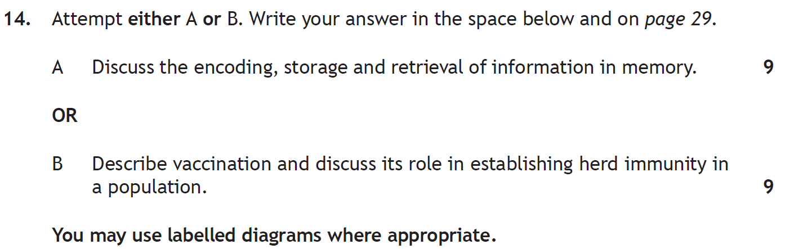
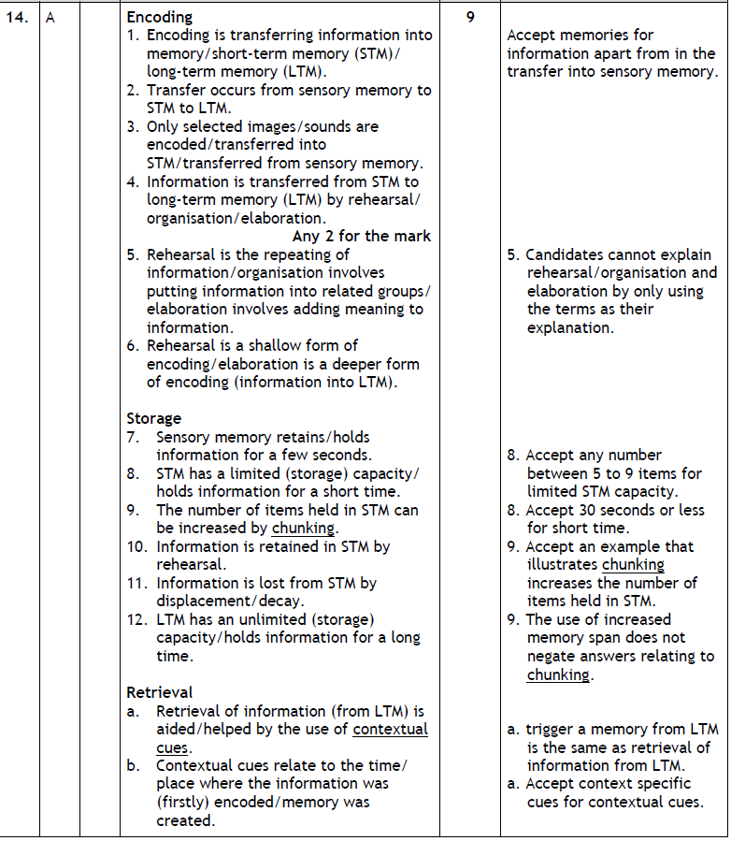
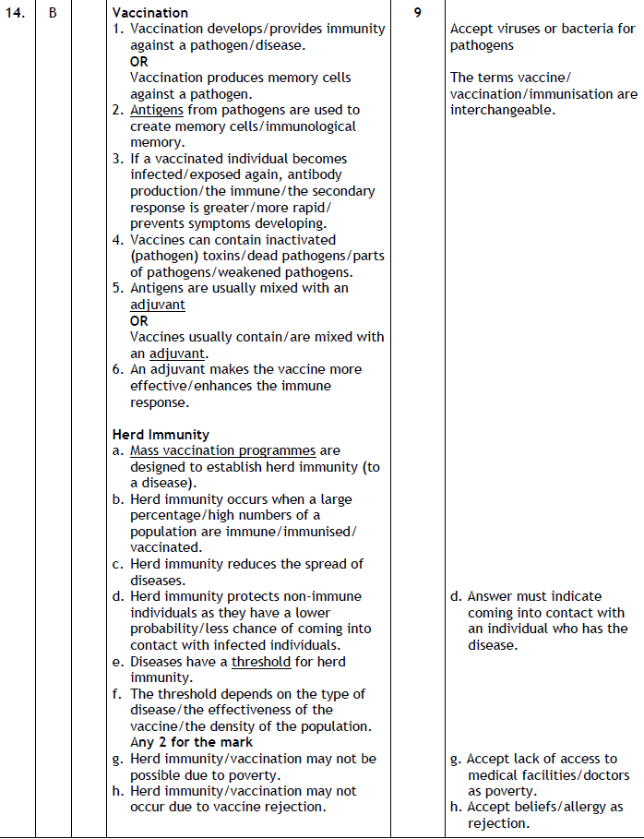

2023
Describe the contents of vaccines and the design of clinical trials used to establish their effectiveness. (9)
